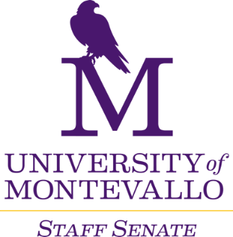

**Thursday, July 11, 2024**

**Merrill Room**

**10 a.m.-12 p.m.**

**AGENDA**

1. Welcome
2. Approval of June minutes
3. Old Business
   1. Staff Salary Policy draft review
   2. Officer nominations for 2024-2025
      1. Voting to be completed by Microsoft Forms
4. Reports from Departments
   1. Updates
5. Staff Senate Committees meet
   1. Campus Communications
   2. Events, Service and Recognition – Shine Award nomination reminder
   3. Finance and Staff Salary Review
   4. Policies and Procedures
   5. Professional Development
6. Next Meeting
   1. August 1