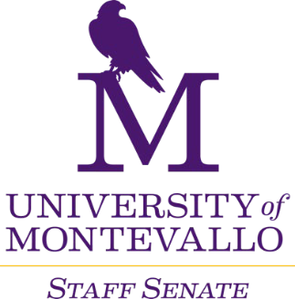

**Thursday, March 7th 2024 Merrill Room**

**10 a.m.-12 p.m.**

**AGENDA**

1. Welcome
2. Approval of February minutes
3. Old Business
   1. Staff Salary Policy
      1. What is the new survey going to look like
         1. 2 vs 3 questions
   2. Swell Being
   3. Staff Survey – April
   4. Shine Award
4. New Business
5. Reports from Departments
   1. Share good news to Vallo Voice
   2. Updates
6. Staff Senate Committees meet
   1. Campus Communications
   2. Events, Service and Recognition – Bricks / Shine Award / Fall Convocation
   3. Finance and Staff Salary Review
   4. Policies and Procedures
   5. Professional Development – Tech Tuesday
7. Next Meetings
   1. March 21st
   2. April 4th & 18th
   3. May 2nd